

**Ahsanullah University of Science & Technology**

**Department of Computer Science & Engineering**

**Course No. :** CSE 4108

**Course Name :** Artificial Intelligence Lab

**Assignment No. :** 01

**Submitted To :**

Md. Siam Ansary Tonmoy Hossain

Department of CSE, AUST Department of CSE, AUST

**Submitted By:**

Name : Sanjida Akter Ishita

ID No. : 170204089

Session : Fall 20

Section : B

Lab group : B2

**Date of Submission:** July 7, 2021

**QUESTION 3:**

**Modify the Python and Prolog codes demonstrated above to find the grandparents of somebody.**

**ANSWER TO THE QUESTION NO 3:**

Here is the modification of code in python and prolog to find the grandparents of somebody.

**Code in prolog:**

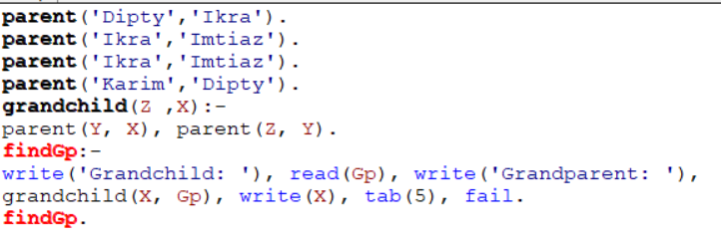

**Input and output:**

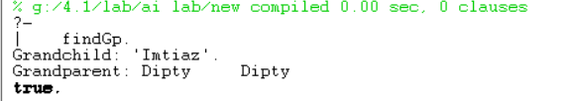

**Code in Python:**

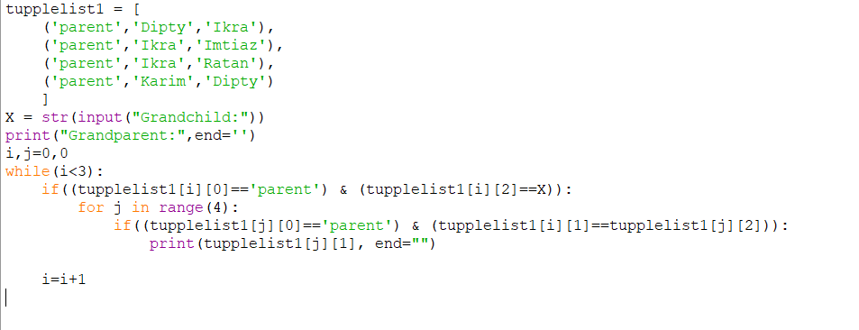

**Input And Output:**

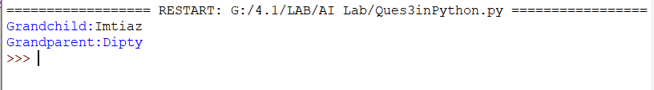

**QUESTION 4:**

**Enrich the KB demonstrated above with ‘brother’, ‘sister’, ‘uncle’ and ‘aunt’ rules in Python and Prolog.**

**ANSWER TO THE QUESTION NO 4:**

Here are our prolog and python code with brother, sister, uncle and aunt rules and show how to find these relations.

**Prolog Code:**

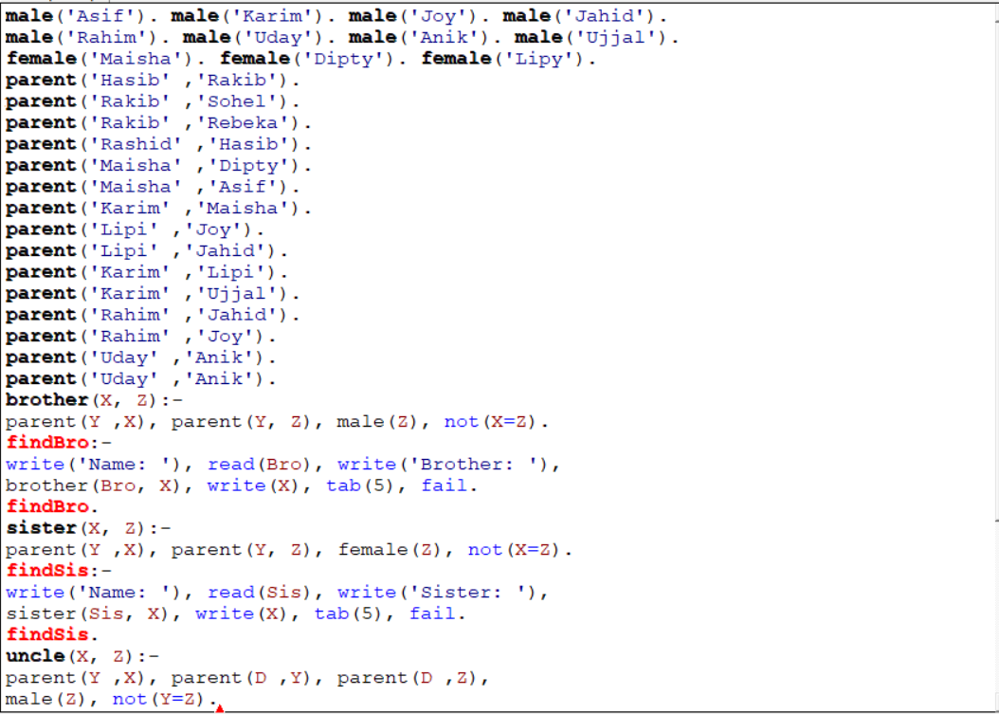

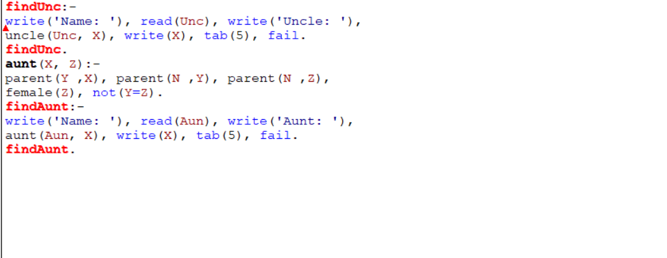

**Input And Output**

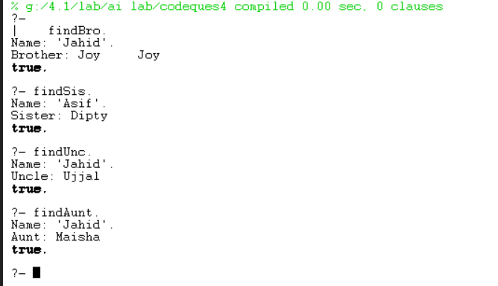

**Python Code:**

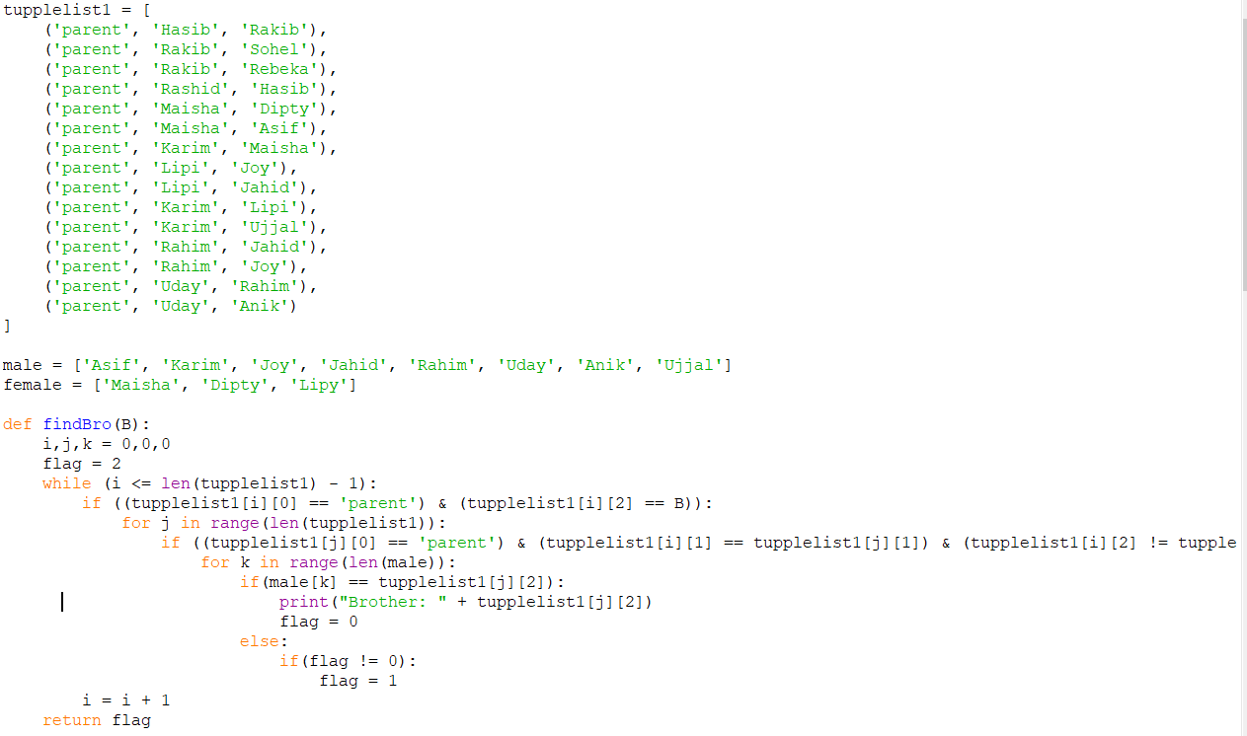

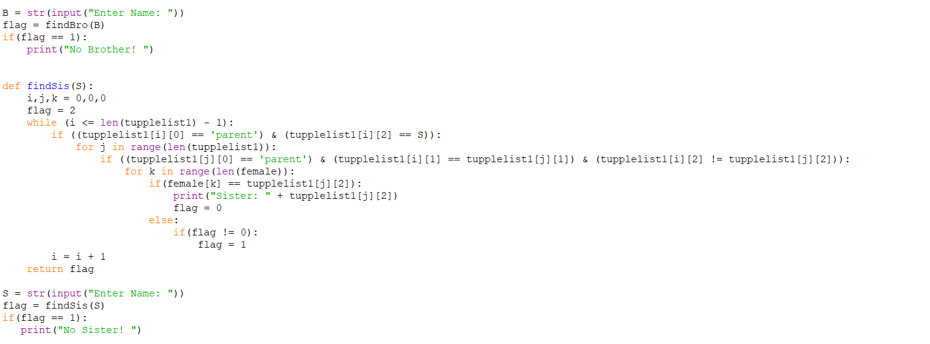

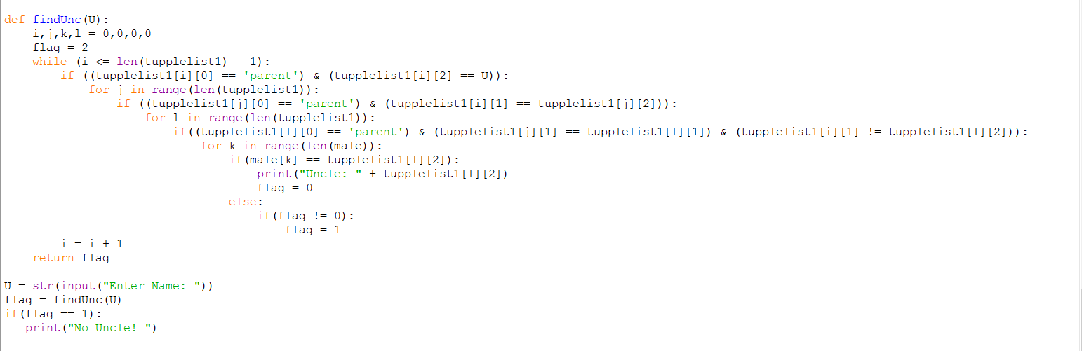

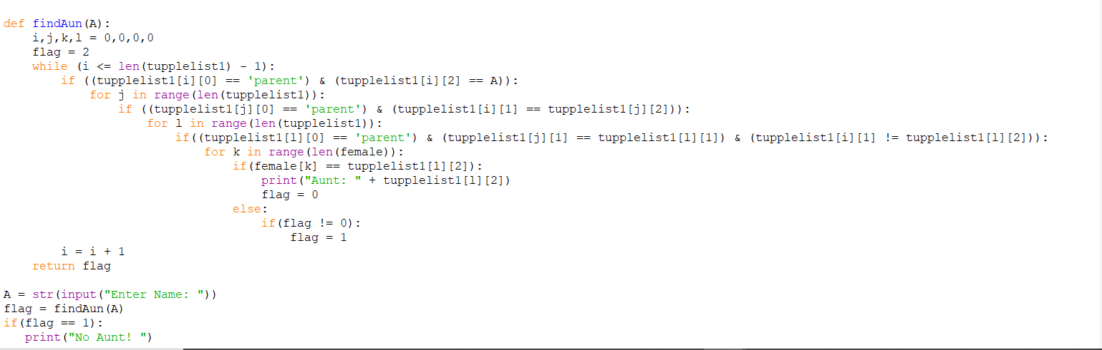

**Input And Output:**

